OPSC 7311 Assignment 1

2017

Adrian Beukes 15002426

**Content**

Introduction ………………………………………………………………………..2

Specifications ………………………………………………………………………..2

Flow Charts ………………………………………………………………………..3

UML Diagrams ………………………………………………………………………..4

Test Data ………………………………………………………………………..5

Help ………………………………………………………………………..8

Feedback ………………………………………………………………………..9

Conclusion ………………………………………………………………………..9

**Introduction:**

The purpose of this assignment is to develop a simple android game, one that would be easy to use, understand, and doesn’t place too much stress on the hardware.

I decided to go with a simple slot machine game. Called Car Slots, it’s a twist on the simple slot machine games, placing a great new twist into the game, by adding the feature of new icons, by replacing the classics with new and exciting car icons.

**Specifications:**

For my game application we were met with the following specification that needed to be achieved

Functional Requirements:

The requirements for this project was:

* Keep it simple
* Don’t strain the hardware
* Have a How to Play section
* Functioning Game
* Attractive UI
* How to play

All of the above which was met, with the added functionality, and great design.

**Flow Chart:**

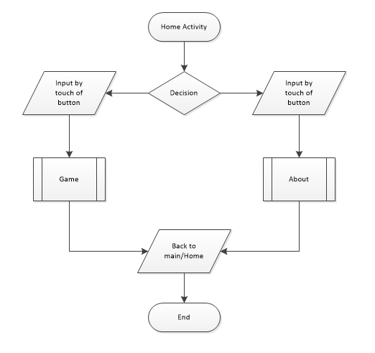

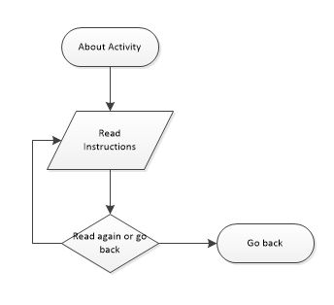

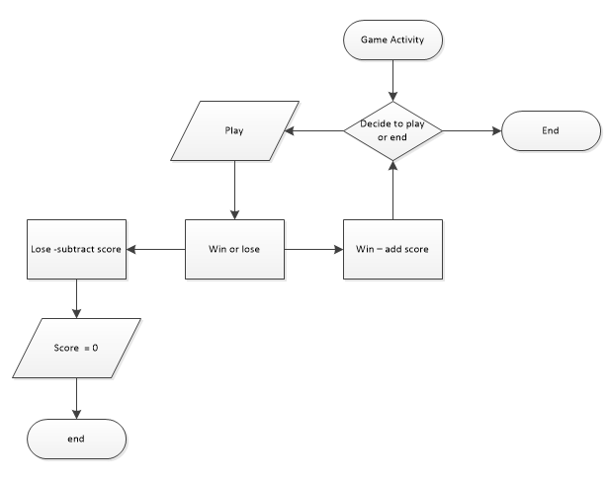

**UML Diagram**

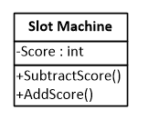

**Test Data**

A few screenshots of my program will follow, with explanation of what’s happening at each stage, as I progress in order to test it:

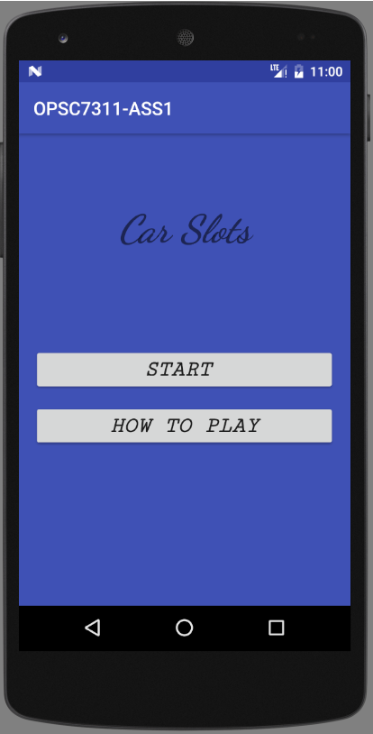

This is the main menu, and the activity you will see upon start up

From this activity, you can find out how to play the game, or jump right into it and start the game.

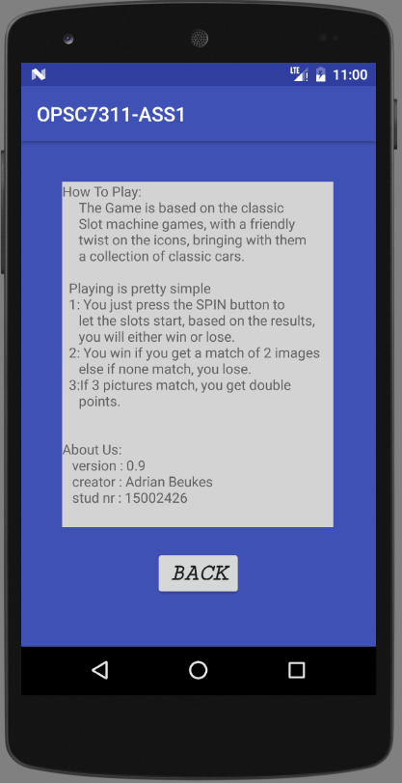

This is the about screen, which gives you a bit more detail about the game. What it is based upon.

Following that are the instructions on how the game works.

As well as information upon the application, etc version, creator, student nr.

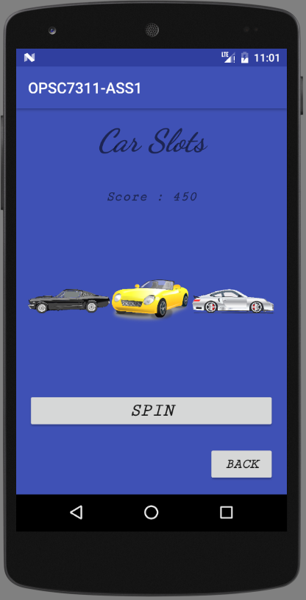

This is the actual game footage.

Here you are able to play the game, by pressing the spin button, it will be followed by an animation of the slots spinning, and upon the end of the spin, it will let you know if you got a match or not.

The spin takes 50 points of the score if no match was made, but adds value for every match made.

The game will end if the user has no more points left.

**Help:**

This is a guide that would take you step for step through the application.

On opening the application you will find yourself at the Home/Main Menu Activity.

Here you will find yourself with the option, to see how to play the game, or just jump straight into it and find out for yourself.

The options of which you choose, are decided upon the button click.

If you find yourself in the How to play the game Activity.

This activity is will follow with instructions on how to play the game, give more detail about the game, as well as information regarding the application, there is also a option to go back to the main menu.

If you find yourself in Game Activity, you will find the screen has a spin button, which activates the animation, rolling the slots, by the end of the roll, it will let you know if you have a match or if you lose, you will be able to continue this process, ranking up points, or until you run out of points.

**Feedback:**

|  |  |
| --- | --- |
| Comments | Action |
| UI Doesn’t work well in landscape | Fixed the issue by inserting portrait view only allowed |
| Animation can be better with scale of motion | Resized all images to be the same, gives slightly better rolling effect |
| Add increase difficulty | Added more car images from 5 to 7, that way it makes it harder to score so often, but yet still fun and keeps the game going |

**Conclusion:**

I really enjoyed working on this project and think it’s some of the best work I have done.

It’s a fun addictive game, and I found myself playing it for a while.

It really helped me to discover what is possible with a few basic lines of code, and leads me wondering what more I can develop.